Assignment 25.1

Problem Statement: Write a Hive program to find the number of medals won by each country in swimming.

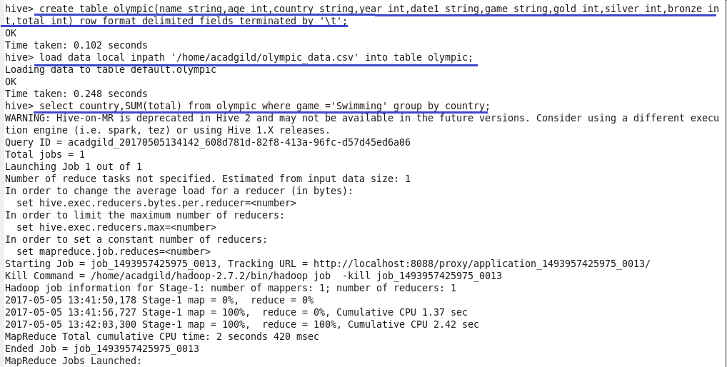

Output

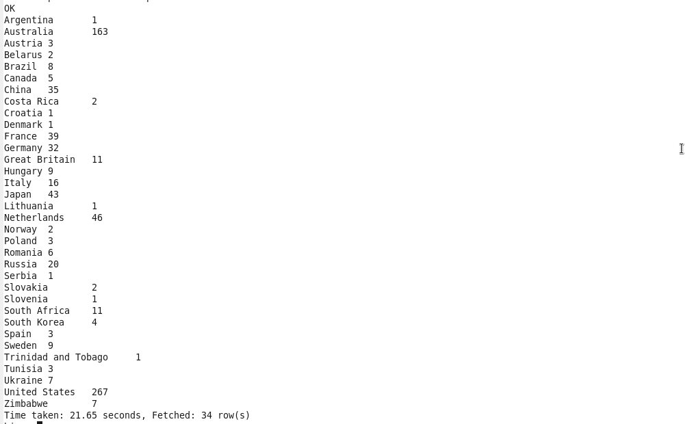

Problem Statement: Write a Hive program to find the number of medals that India won year wise.

